Chemistry IGCSE Paper 6 revision guide
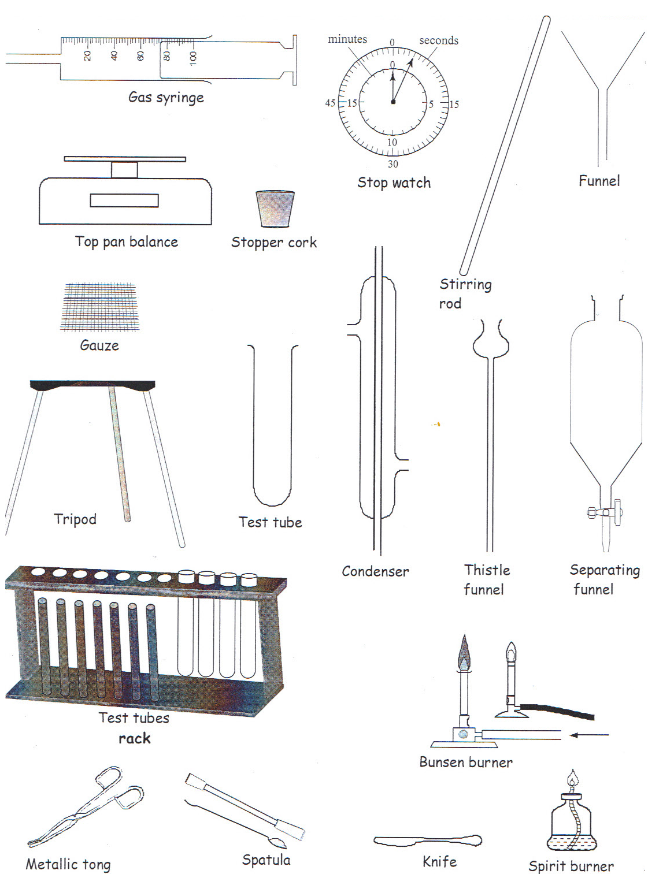
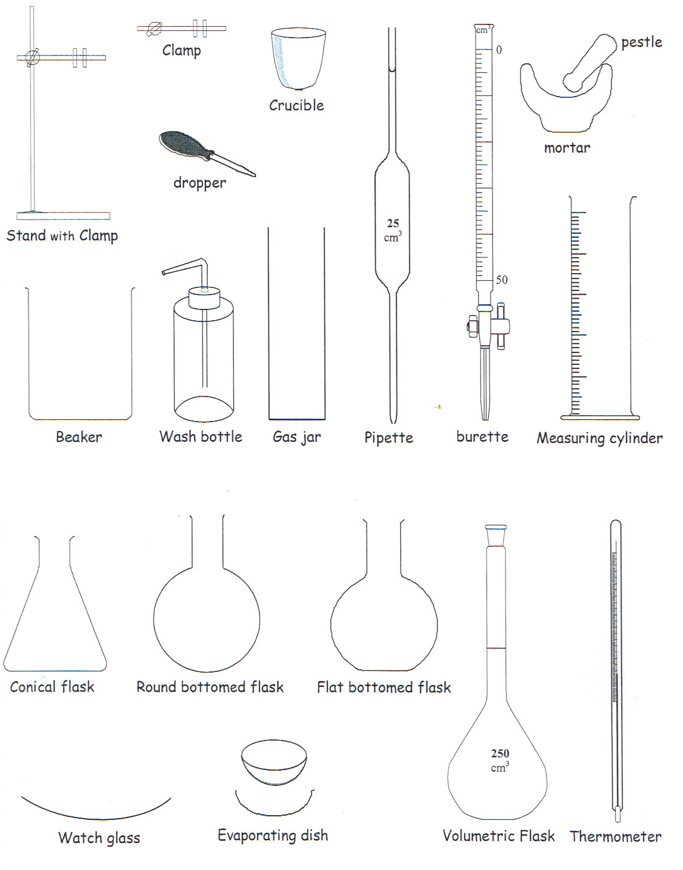

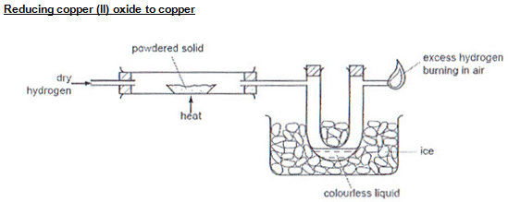
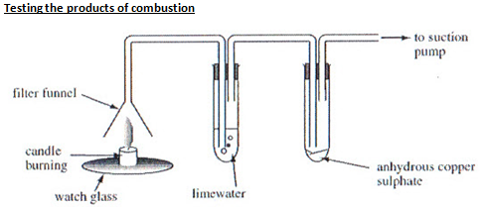
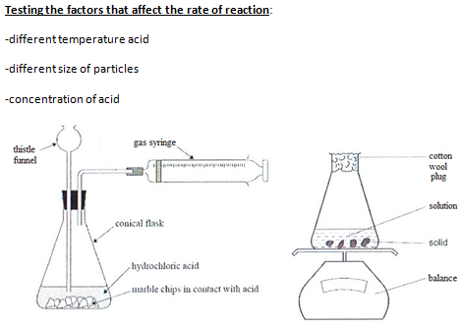

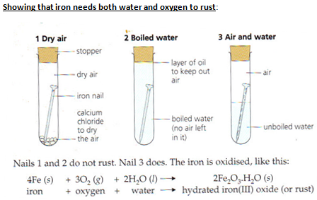
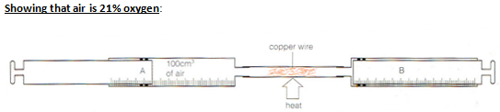
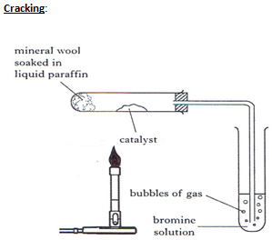

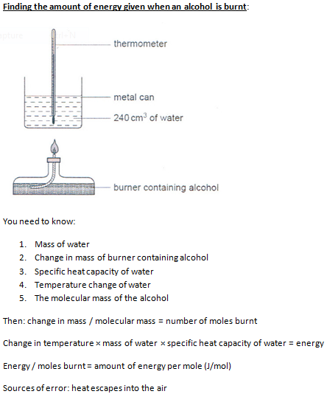
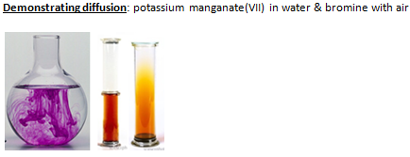
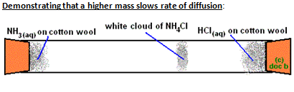

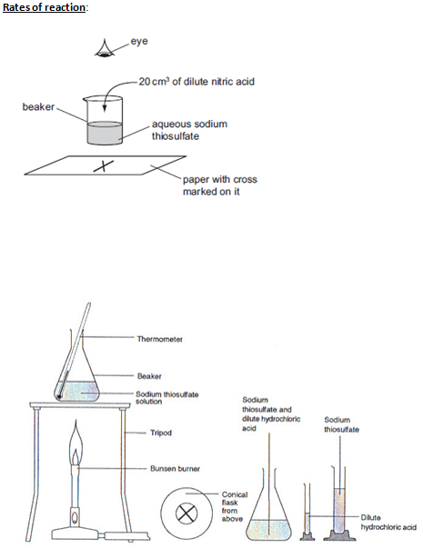
You can change the temperature and concentration used (not both at the same time though)
You need to keep the diameter of the conical flask the same, if it is thinner then the cross will disappear sooner, the cross also has to be the same, volumes too

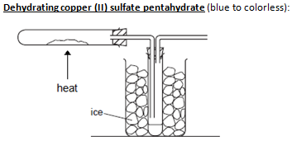

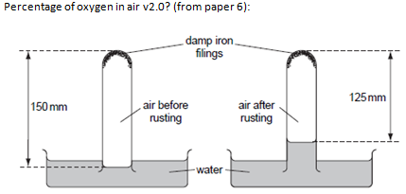
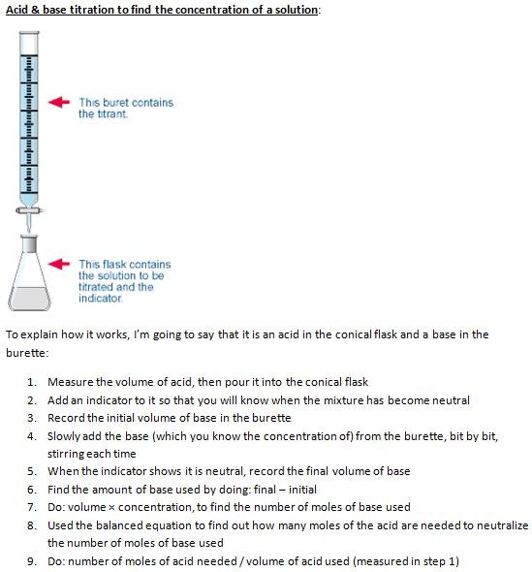
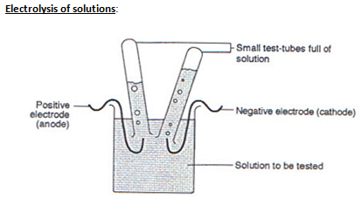
(This set up is mostly if you want to test the gases, otherwise you can use the standard set up)
The limestone cycle:
- Burn the limestone chip/ limestone powder in a test tube in a Bunsen flame → calcium oxide
- Put calcium oxide in water → calcium hydroxide solution + left over limestone
- Filter the leftover limestone
- Blow bubbles using a straw into the calcium hydroxide solution → limestone
Flame colors: (I copied a table from the internet because it isn’t in the book, the ones in red I’m pretty sure you have to know, and the ones in the yellow are the ones I think are good to know since they are used often).
Symbol | Element | Color
As | Arsenic | Blue
B | Boron | Bright green
Ba | Barium | Pale/Yellowish Green
Ca | Calcium | Orange to red
Cs | Cesium | Blue
Cu(I) | Copper(I) | Blue
Cu(II) | Copper(II) non-halide | Green
Cu(II) | Copper(II) halide | Blue-green
Fe | Iron | Gold
In | Indium | Blue
K | Potassium | Lilac to red
Li | Lithium | Magenta to carmine
Mg | Magnesium | Bright white
Mn(II) | Manganese(II) | Yellowish green
Mo | Molybdenum | Yellowish green
Na | Sodium | Intense yellow
P | Phosphorus | Pale bluish green
Pb | Lead | Blue
Rb | Rubidium | Red to purple-red
Sb | Antimony | Pale green
Se | Selenium | Azure blue
Sr | Strontium | Crimson
Te | Tellurium | Pale green
Tl | Thallium | Pure green
Zn | Zinc | Bluish green to whitish green

Sources of error for the flame test:
- The test cannot detect low concentrations of most ions.
- The brightness of the signal varies from one sample to another. For example, the yellow emission from sodium is much brighter than the red emission from the same amount of lithium.
- Impurities or contaminants affect the test results. Sodium, in particular, is present in most compounds and will color the flame. Sometimes a blue glass is used to filter out the yellow of sodium.
- The test cannot differentiate between all elements. Several metals produce the same flame color. Some compounds do not change the color of the flame at all.
Separation methods:
-Paper chromatography: (To separate substances) a drop of the substance is placed at the centre of a piece of filter paper and allowed to dry. Three or four more drops are added to it. Water is dripped on, drip by drip, so the ink spreads creating different coloured circles. Paper + rings = chromatogram. Rings are created because different substances travel at different rates.
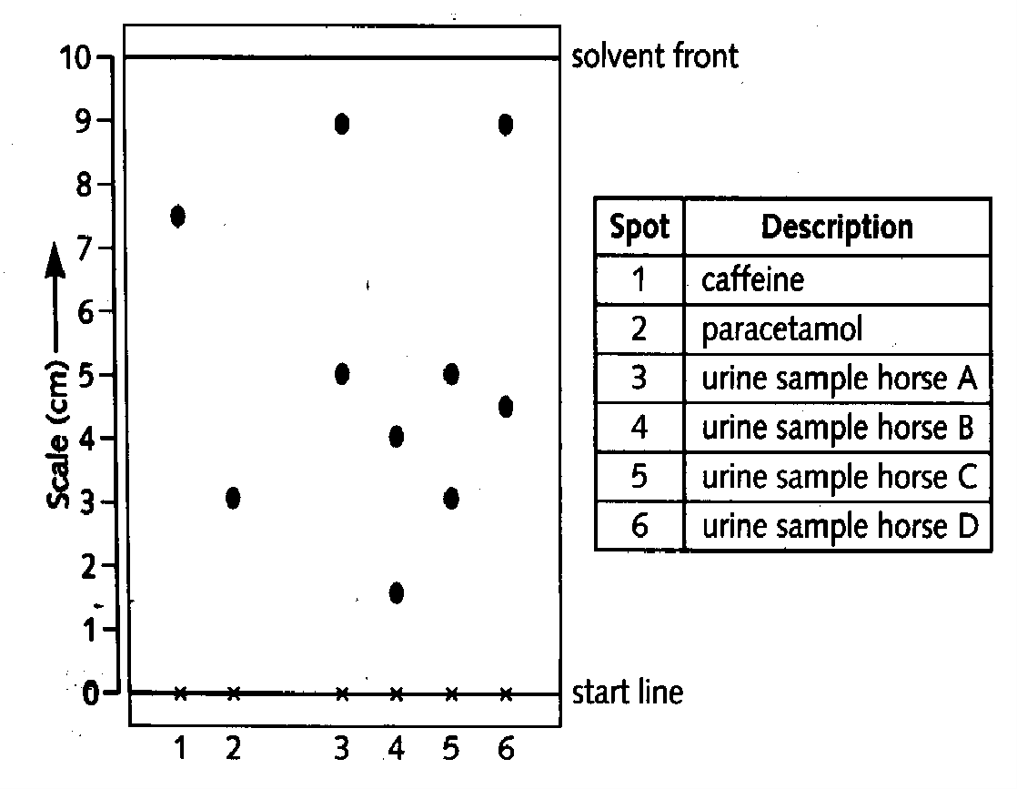
(To identify substances) Spots of substances placed onto a pencilled line (as ink would separate) and labelled. Paper goes in solvent, and solvent travels up paper, then paper is taken out. There are spots which have travelled different distances.
-Interpreting simple chromatograms:
1. Number of rings/dots = number of substances
2. If two dots travel the same distance up the paper they are the same substance.
3. You can calculate the R_{f} value to identify a substance, given by the formula:
R_{f} value = distance moved by substance / distance moved by solvent
To make colourless substances you use a locating agent: 1. Dry paper in oven 2. Spray it with locating agent 3. Heat it for 10 minutes in oven.
The stationary phase is the material on which the separation takes place (e.g. the paper).
The mobile phase consists of the mixture you want to separate, dissolved in a solvent.
- Pure substances have a definite, sharp meting/boiling point; a substance + impurity has lower melting point and higher boiling point, at a range of temperatures; more impurity means bigger change.
-Filtration: Mixture goes in a funnel with filter paper, into a flask. Residue is insoluble and stays at top. Filtrate goes through.

Distillation:
Simple distillation (left picture below) evaporates a solvent from a solution.
Fractional distillation (right picture below) removes a liquid from a mixture of liquids, because the liquids have different boiling points. Used to separate substances in crude oil and get ethanol from the products of fermentation.
1. mixture is heated to evaporate the substance with the lowest boiling point
2. some of the other liquid(s) will evaporate too. A mixture of gases condense on the beads in the fractional column. So the beads are heated to the boiling point of the lowest substance in this case, so that the substance being removed cannot condense on the beads. The other substances continue to condense and will drip back into the flask.
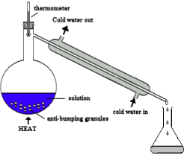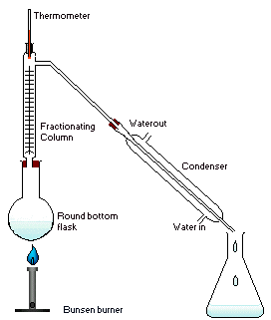
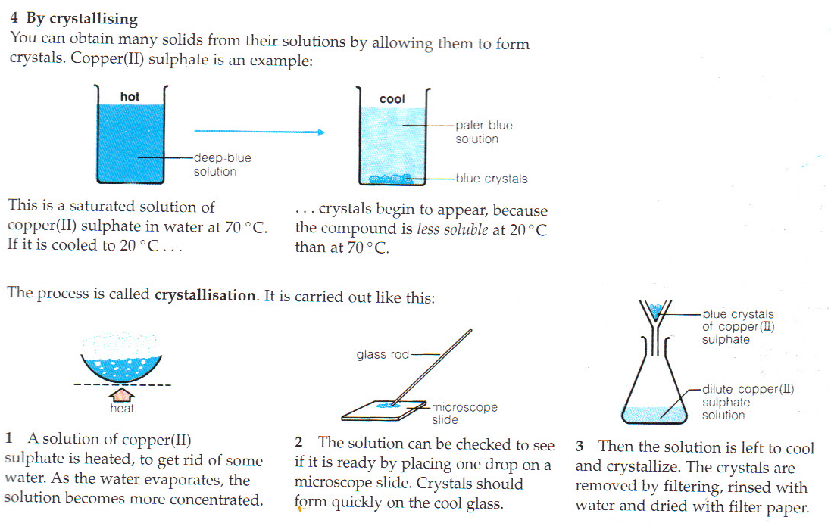
Using a suitable solvent:
Solvent | It dissolves
water | see “soluble salts” in section 8.3 and sugar
white spirit | gloss paint
propanone | grease, nail polish
ethanol | glues, printing inks, scented substances in perfumes and aftershaves

Choosing a suitable separation method:
Method of separation | Used to separate
filter | a solid from a liquid
evaporate | a solid from a solution
crystallise | a solid from a solution
distil | a solvent from a solution
fractional distillation | liquids from each other
chromatography | different substances from a solution
Percent yield = amount of wanted substance / total amount of substance
More colors:
-potassium iodide will go from colourless to red-brown, it is a reducing agent, it therefore is oxidised to produce I₂
H₂O₂ + 2KI + H₂SO₄→ I₂ + K₂SO₄ + 2H₂O
2I⁻ (colourless) → I₂ (red-brown)
-Potassium mangenate, an oxidising agent, will go from purple to colourless. (Recall of equations involving KMnO4 is not required.)
-potassium dichromate, an oxidising agent: Cr₂O₇²⁻ (orange) → 2Cr³⁺ (green)
Preparing salts in the lab (all on pages 124 and 125)
Starting with a metal:
- Add excess metal to an acid
- When bubbling (hydrogen) stops the reaction is done
- Filter off excess metal (because a metal is a solid, except mercury)
Starting with an insoluble base:
- Add insoluble base to acid and heat gently, it will dissolve
- Keep adding until no more dissolves (reaction is done)
- Filter out the insoluble (excess) base
(Titration): Starting with an alkali (soluble base):
- Put a certain amount (e.g. 25cm³) alkali in a flask
- Add phenolphthalein (pink in alkaline, colourless in acid or neutral) you could use a different indicator but this is quite simple
- Add acid from a burette, slowly while stirring, until it goes colourless
- Find out how much acid you used (using the scale on the burette.
- Repeat, this time add the same amount of base, but you know exactly how much acid to add to get a neutral solution, don’t add indicator though (you don’t need it anymore, and it would make it impure)
- Evaporate the water from the neutral solution using a Bunsen flame and an evaporating dish
Add acid to base in a beaker
-if the salt is insoluble then filter it
-if is soluble then evaporate using an evaporating dish sat on top of a beaker of water on top of a Bunsen flame. When crystals start to form around the edge stop heating and leave to cool for a few days to form crystals, then filter crystals.
If they don’t tell you if the salt is soluble or not then you need to know this:
Soluble salts are:
-all potassium, sodium and ammonium salts
-all nitrates
-all halides except silver and lead
-all sulphates except calcium, lead and barium
Insoluble salts are:
-carbonates except potassium, sodium and ammonium
-silver and lead halides
-calcium, lead and barium sulphates

Aqueous cations:
Test | Ion | Result
Add a few drops of dilute sodium hydroxide solution. A precipitate will form. | Cu²⁺ | Pale blue precipitate
 | Fe²⁺ | Green precipitate
 | Fe³⁺ | Red-Brown precipitate
 | Al³⁺, Zn²⁺, Ca²⁺ | White precipitate
Divide the solutions into two equal volumes. To one, add double the volume of sodium hydroxide solution. To the other, add double the volume of ammonium hydroxide. | Al³⁺ | The precipitate dissolves again in sodium hydroxide solution giving a colourless solution.
 | Zn²⁺ | Precipitate dissolves in both solutions, giving a colourless solution.
 | Ca²⁺ | Dissolves in neither.
Take a small amount of the solid or solution. Add a little dilute sodium hydroxide solution and heat gently. | NH₄⁺ | Ammonia gas given off (it has a strong sharp smell and turns red litmus blue)

Anions:
Test | Ion | Result
Take a small amount of the solid/solution. Add a little dilute hydrochloric acid. | Carbonate | Carbon dioxide gas is produced so there are bubbles and limewater goes milky
Take a small amount of the solution. Add an equal volume of dilute nitric acid. Then add silver nitrate solution. Silver halides are insoluble, so a precipitate forms. | Chloride | White precipitate
 | Iodide | Yellow
Take a small amount of the solution. Add a little sodium hydroxide solution. Add aluminium foil and heat gently. | Nitrate | Ammonia gas given off
Take a small amount of the solution. Add an equal volume of dilute hydrochloric acid. Then add barium nitrate solution. Barium sulphate is insoluble so... | Sulphate | White precipitate (barium sulphate)

Gases:
Test | Gas | Result
Smell gas, use indicator paper. | Ammonia | Recognizable odour, indicator paper turns blue
It is a weak acid, so reacts with calcium hydroxide (lime water) to form insoluble calcium carbonate | Carbon Dioxide | white precipitate, solution goes milky
Green poisonous gas which bleaches dyes. Hold damp indicator paper in the gas (in a fume cupboard). | Chlorine | Indicator paper turns white.
Collect in a tube then put a lighted splint to it. | Hydrogen | Squeaky pop
Collect in a tube then put a glowing splint to it. | Oxygen | Splint immediately bursts into a flame

Other tests:
Test | Substance | Result
Add some drops of the substance to white anhydrous copper (II) sulphate | water | White crystals go blue
Add to blue cobalt chloride paper | water | Goes pink
Test for saturation: add bromine water | Alkene | Goes from orange to colorless
Test for saturation: add bromine water | alkane | Stays orange
Blue litmus paper | acid | Goes red
Add a metal carbonates | acid | Effervescence (CO₂)
Red litmus paper | base | Goes blue

Observable properties
For the following properties, I put the ones you might observe in the lab (i.e. brittle green crystal but not diatomic molecule since you can’t see that).

Alkali metals properties that might be on paper 6
-React violently with chlorine
-Burst into flames when heated with oxygen:
-a red flame for lithium
-a yellow flame for sodium
-a lilac flame for potassium
-Produce soluble white compounds.
-React with cold water
-Conducts electricity
Halogens, group 7 – physical properties:
-form coloured gases
-are poisonous
-are brittle and crumbly in solid form
-do not conduct electricity
Transition metals
-hard, tough and strong
-high melting points (except mercury)
-malleable (can be hammered into different shapes) and ductile (can be drawn out into wires)
-good conductors of heat and electricity (silver is the best)
-high density (greater than water’s density)
-Much less reactive than group one metals, except for iron which rusts easily
-Have no trend in reactivity
-Mostly form coloured compounds
-Can form several differently charged ions: have variable valency, therefore.....
-they can form more than one compound with another element
-can be used as catalysts
-can form complex ions
Indicators
Indicator | Colour in acid | Colour in alkali
Litmus | Red | Blue
phenolphthalein | Colourless | Pink
Methyl orange | red | yellow
Universal indicator can be used as a solution or paper strip:
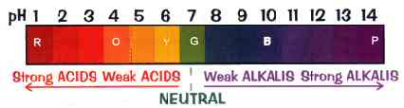
Preparing gases in the lab:
To make.... | Place in flask: | Add.... | Reaction
CO₂ | CaCO₃ (marble chips) | Dilute HCl | CaCO₃(s) + HCl(aq) → CaCl₂(aq) + H₂O(l) + CO₂(g)
Cl₂ | Manganese (IV) oxide  (as an oxidising agent) | Conc. HCl | 2HCL(aq) + [O] → H₂O(l) + Cl₂(g)
H₂ | Pieces of zinc | Dilute HCl | Zn(s) + SHCL(aq) → ZnCl₂(aq) + H₂(g)
O₂ | Manganese (IV) oxide  (as a catalyst) | Hydrogen peroxide | 2 H₂O₂(aq) → 2H₂O(l) + O₂(g)

Collecting gases:
Method | Upward displacement of air | Downward displacement of air | Over water | Gas syringe
Use when... | Gas more dense than air | Gas less dense than air | Gas is sparingly soluble in water | To measure the volume
Apparatus | 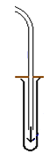 | 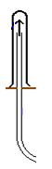 | 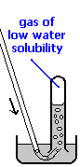 | 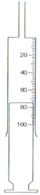
Examples | Carbon dioxide, chlorine, sulphur dioxide, hydrogen chloride | Ammonia, hydrogen | Carbon dioxide, hydrogen, oxygen | Any gas

