Space physics
Earth and the Solar System,
Earth is a planet that orbits the Sun once in approximately 365 days
Earth revolves around the sun in 365 days, 5 hours, 59 minutes and 16 seconds. The time a planet takes to revolve around the sun is called a year.
The Earth orbits around the sun every 365.25 days.
It takes a little more than 365 days for the Earth to make a complete trip around the sun. Other planets have different orbital times. It takes only 87 days for Mercury to orbit the sun, but 12 years for Jupiter to make the journey.
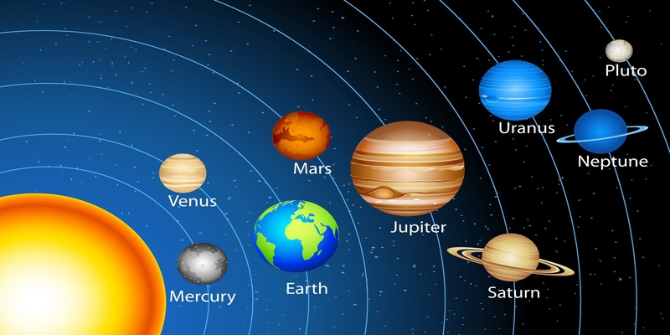

Orbit of the Earth around the Sun is an ellipse which is approximately circular
Earth's orbit is not a perfect circle. It is elliptical, or slightly oval-shaped. This means there is one point in the orbit where Earth is closest to the Sun, and another where Earth is farthest from the Sun. The closest point occurs in early January, and the far point happens in early July
Why is the Earth's orbit elliptical not circular?

The reason orbits are not circular is illustrated by Newton's universal law of gravity, which postulates that the force of gravity weakens as the square of the distance between the two objects
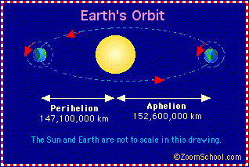
Earth rotates on its axis, which is tilted, once in approximately 24 hours
Earth rotates on its axis; this causes us to experience day and night. But Earth's axis is tilted 23.5 degrees
The Earth's axis runs from the North Pole to the South Pole. It takes the Earth 24 hours, or one day, to make one complete rotation around this invisible line. ... So the Earth rotates around its axis as it revolves around the sun. It takes the Earth 365 days, or one year, to complete a revolution.
It takes approximately one month for the Moon to orbit the Earth
It takes 27 days, 7 hours, and 43 minutes for our Moon to complete one full orbit around Earth. This is called the sidereal month, and is measured by our Moon's position relative to distant “fixed” stars. However, it takes our Moon about 29.5 days to complete one cycle of phases (from new Moon to new Moon).
Knowing how this dance between the Moon, Earth and Sun plays out lets us understand the Moon's constantly changing appearance. Moon fact: The Moon's phases repeat every 29.5 days, but it's orbit around the Earth only takes 27. Why? In that time, as our Moon moves around Earth, the Earth also moves around the Sun.
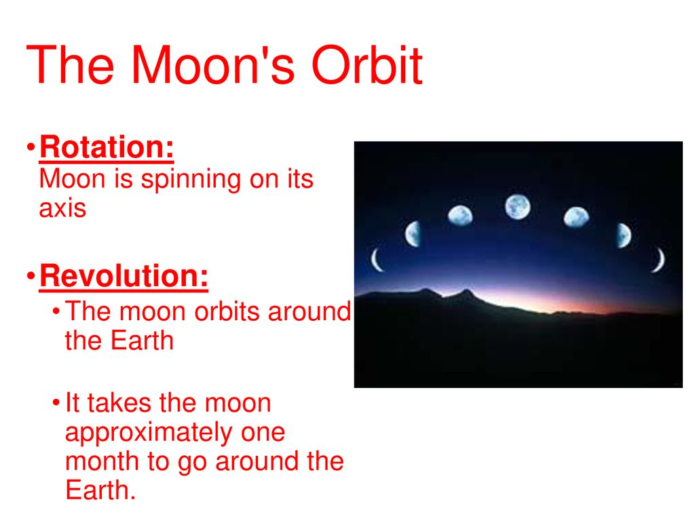
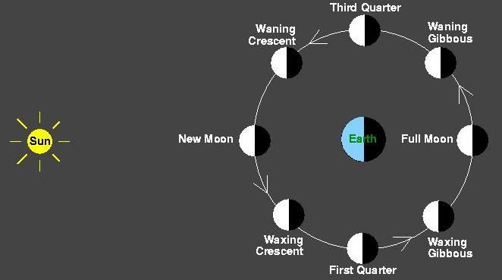

It takes approximately 500 s for light from the Sun to reach the Earth
The Sun's distance from the Earth is 150 million kilometers. Its light travels at a speed of 300,000 kilometers per second. So it takes 500 seconds or nearly eight and a half minutes, for the Sun's light to reach the surface of our planet.
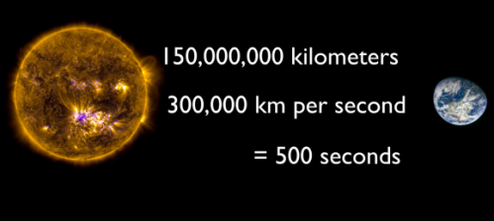
Define average orbital speed from the equation
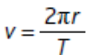
Where r is the average radius of the orbit and T is the orbital period; recall and use this equation
In gravitationally bound systems, the orbital speed of an astronomical body or object (e.g. planet, moon, artificial satellite, spacecraft, or star) is the speed at which it orbits around either the barycenter or, if one object is much more massive than the other bodies in the system, its speed relative to the center of mass of the most massive body.
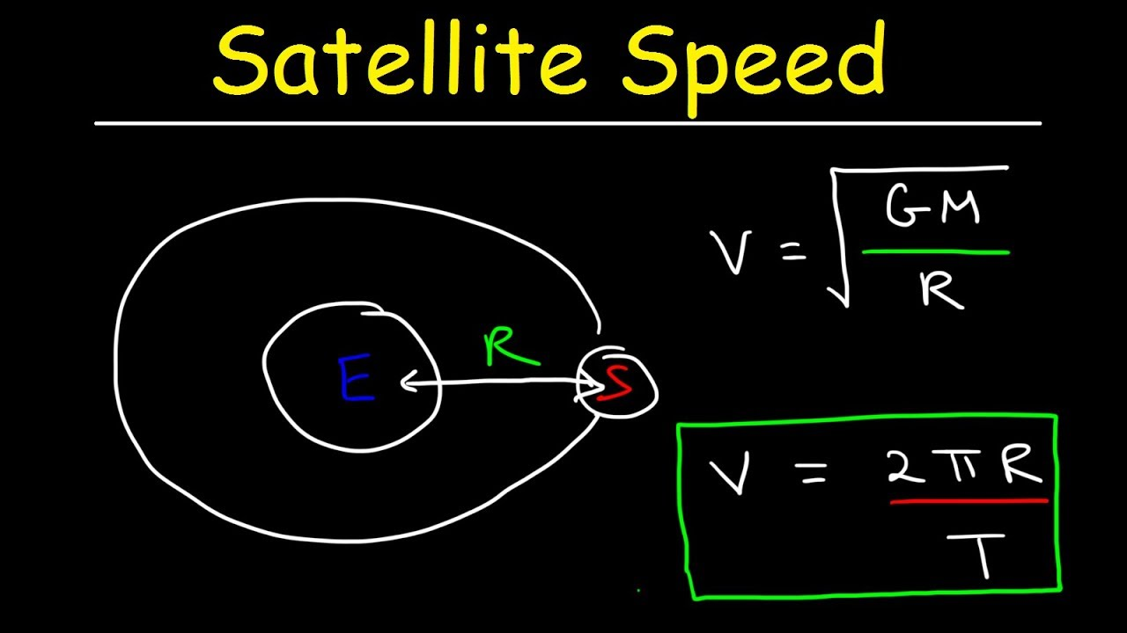

The Solar System

Our solar system consists of our star, the Sun, and everything bound to it by gravity – the planets Mercury, Venus, Earth, Mars, Jupiter, Saturn, Uranus, and Neptune; dwarf planets such as Pluto; dozens of moons; and millions of asteroids, comets, and meteoroids
Minor planets that orbit the Sun
As the authority on the naming and classification of celestial objects, the International Astronomical Union officially recognizes five dwarf planets in the solar system:
- Pluto. Eris. Ceres. Makemake. Haumea.
A dwarf star is a star of relatively small size and low luminosity.
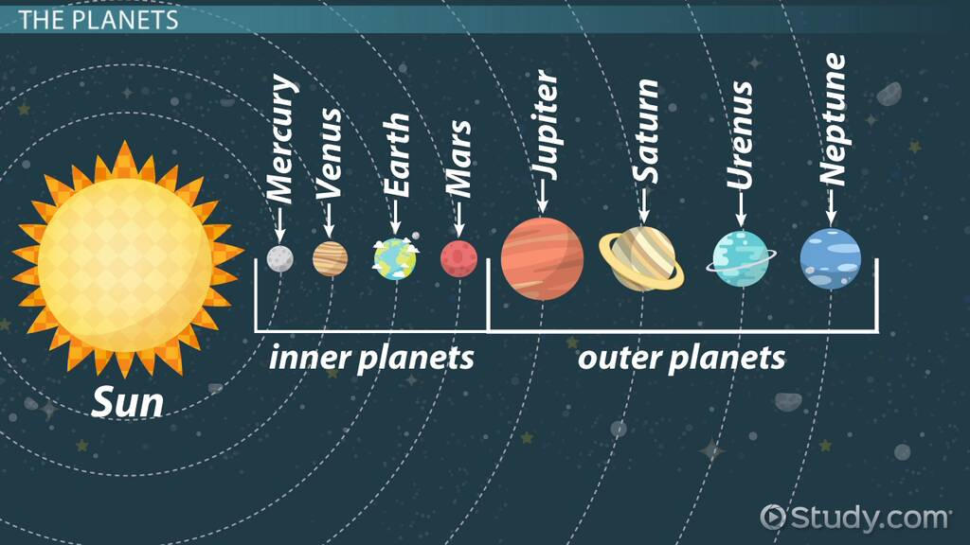
Dwarf planets are worlds that are too small to be considered full-fledged planets, but too large to fall into smaller categories.
In recent years, there's been a lot of hubbub about Pluto losing its status as one of the planets of the solar system. Pluto is no longer considered the ninth planet in the series of major planetary objects, but instead is now just one of the many so-called "dwarf planets." The debate started anew after the New Horizons mission passed by Pluto in 2015, revealing a world of surprising geological complexity. As of 2017, delegates from the mission are trying to get Pluto's planethood status back.
Astronomers estimate that there could be as many as 200 dwarf planets in the solar system and the Kuiper Belt. But the differences between planets and dwarf planets may not be obvious at first.

Asteroid belt
The asteroid belt is a torus-shaped region in the Solar System, located roughly between the orbits of the planets Jupiter and Mars. It contains a great many solid, irregularly shaped bodies, of many sizes but much smaller than planets, called asteroids or minor planets.
The size of the objects within the asteroid belt range from being as small as a dust particle to almost 1000km wide The largest is the dwarf planet Ceres. Ceres is the only dwarf planet in the asteroid belt. The four largest objects in the belt are Ceres, Vesta, Pallas and Hygiea
Moons that orbit the planets
Moons – also known as natural satellites – orbit planets and asteroids in our solar system. Earth has one moon, and there are more than 200 moons in our solar system. Most of the major planets – all except Mercury and Venus – have moons. Pluto and some other dwarf planets, as well as many asteroids, also have small moons. Saturn and Jupiter have the most moons, with dozens orbiting each of the two giant planets.
Moons come in many shapes, sizes, and types. A few have atmospheres and even hidden oceans beneath their surfaces. Most planetary moons probably formed from the discs of gas and dust circulating around planets in the early solar system, though some are "captured" objects that formed elsewhere and fell into orbit around larger worlds.

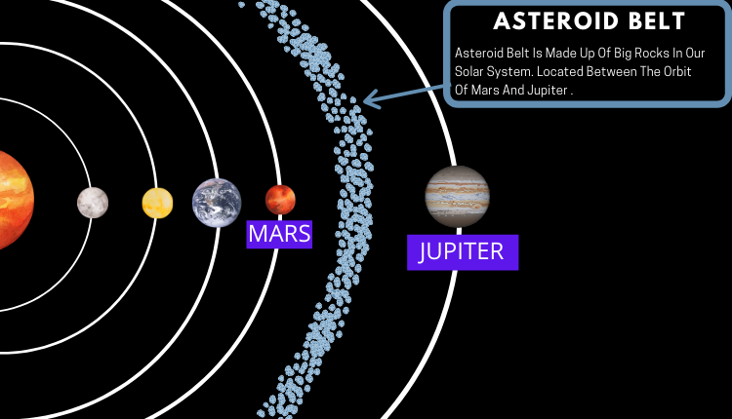
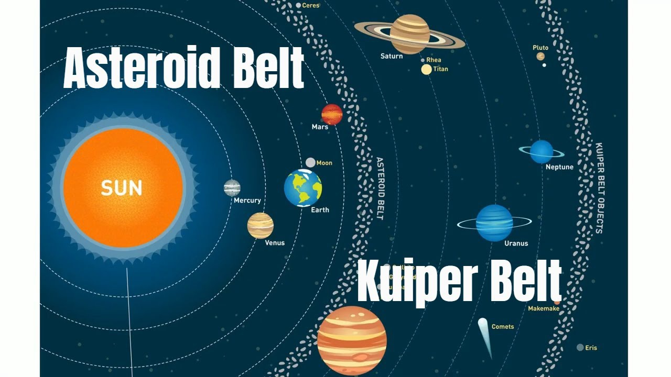
Smaller Solar System bodies, including comets and natural satellites
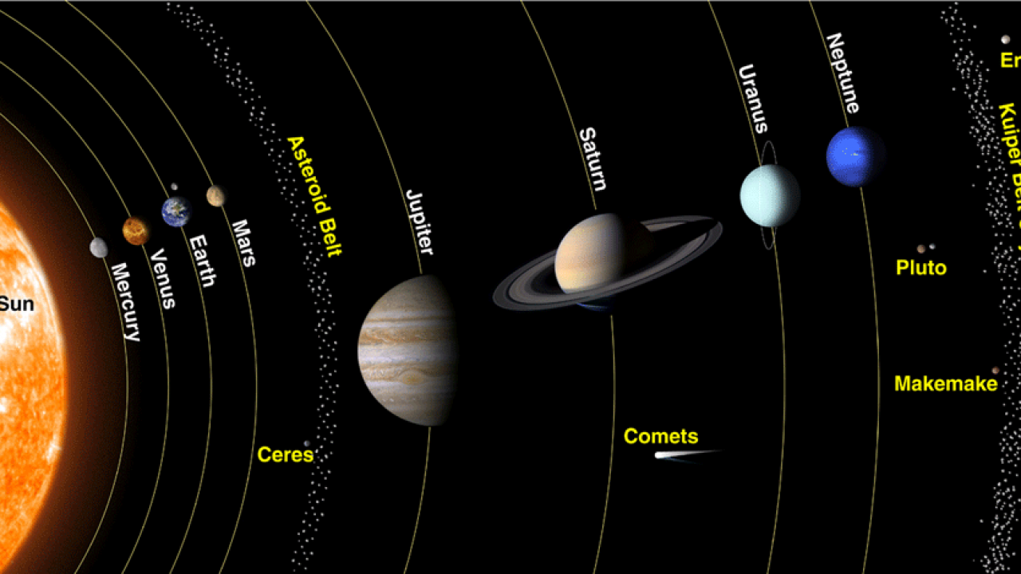
The small bodies in the solar system include comets, asteroids, the objects in the Kuiper Belt and the Oort cloud, small planetary satellites, Triton, Pluto, Charon, and interplanetary dust.
A small Solar System body (SSSB) is an object in the Solar System that is neither a planet, a dwarf planet, nor a natural satellite. The term was first defined in 2006 by the International Astronomical Union (IAU) as follows: "All other objects, except satellites, orbiting the Sun shall be referred to collectively as 'Small Solar System
Planetary data about orbital distance
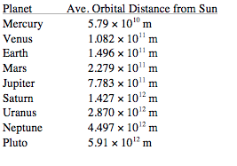
Planetary data about orbital period
Astronomical unit (AU, or au), a unit of length effectively equal to the average or mean, distance between Earth and the Sun, defined as 149,597,870.7 km
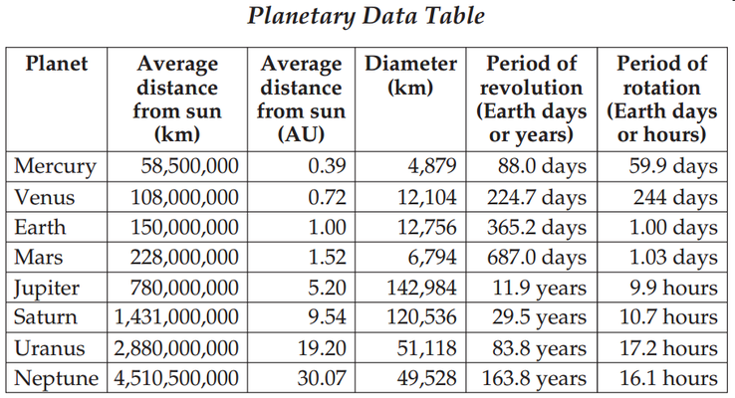
Planetary data about surface temperature

Average Temperature on Each Planet
Planetary surface temperatures tend to get colder the farther a planet is from the Sun. Venus is the exception, as its proximity to the Sun and dense atmosphere make it our solar system's hottest planet. The average temperatures of planets in our solar system are:
- Mercury - 800°F (430°C) during the day, -290°F (-180°C) at night
- Venus - 880°F (471°C)
- Earth - 61°F (16°C)
- Mars - minus 20°F (-28°C)
- Jupiter - minus 162°F (-108°C)
- Saturn - minus 218°F (-138°C)
- Uranus - minus 320°F (-195°C)
- Neptune - minus 331°F (-201°C)
- Pluto - minus 388°F (-233°C)
Planetary data about density
A planet's density is related to its composition. The outer planets are composed primarily of gas, so their overall density is lower. , they are larger in size and much more massive! Saturn is massive and second in size to Jupiter, but its density is so low that it would float in water!
Earth is the densest planet for two reasons: it is made of dense material, and it is heavy. Both points need a bit more elaboration. Compared to a gas giant, Earth is dense! The average chunk of Earth (which is the average value of crust, mantle, all that) weighs over 5.5 grams/cm3.
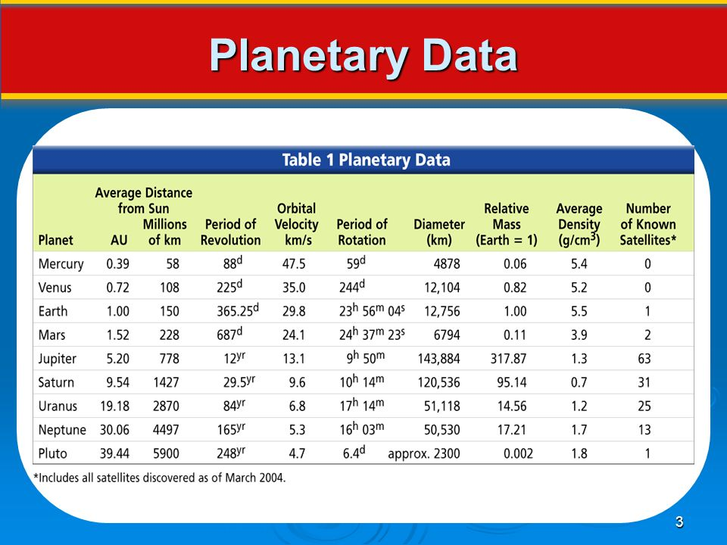
Gravitational field strength at the planet’s surface
At any position, the strength of the gravitational field, or the gravitational field strength, is given by the gravitational force per kilogram. At the surface of the Earth, for example, the strength of the Earth's gravitational field is 9.8 newton / kilogram.
The gravitational field strength decreases as the separation from the planet increases. As you move away from the surface of the planet this dilution of gravity follows a definite inverse square relationship, where distances are measured from the centre of the Earth (or Moon).

Weight, mass and gravitational field strength
The weight of an object is the force on it caused by the gravity due to the planet. The weight of an object and the gravitational field strength are directly proportional. For a given mass, the greater the gravitational field strength of the planet, the greater its weight.
Weight can be calculated using the equation:
Weight = mass × gravitational field strength
Space object | g, gravitational field strength (N/kg)
The Sun (star) | 293.0
Mercury | 3.7
Venus | 8.8
Earth | 9.8
Moon (satellite) | 1.7
Mars | 3.7
Ceres (dwarf planet) | 0.27
Jupiter | 24.7
Saturn | 10.5
Uranus | 9.0
Neptune | 11.7
Pluto (dwarf planet) | 0.49

What defines a dwarf planet?
According to the International Astronomical Union, which sets definitions for planetary science, a dwarf planet is a celestial body that -orbits the sun, has enough mass to assume a nearly round shape, has not cleared the neighborhood around its orbit and is not a moon.
Sun contains most of the mass of the Solar System
The sun lies at the heart of the solar system, where it is by far the largest object. It holds 99.8% of the solar system's mass and is roughly 109 times the diameter of the Earth — about one million Earths could fit inside the sun.
By far most of the solar system's mass is in the Sun itself: somewhere between 99.8 and 99.9 percent. The rest is split between the planets and their satellites, and the comets and asteroids and the dust and gas surrounding our star.
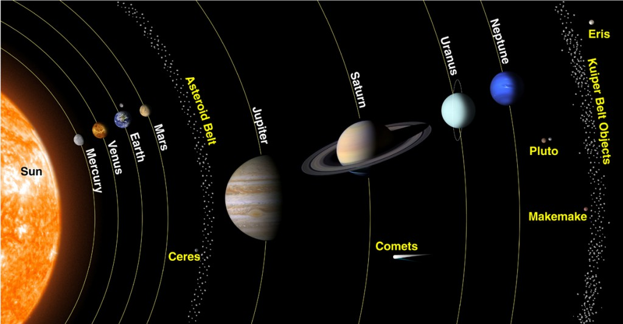

Stars and the Universe

The Sun as a star
Stars are space objects that produces their own energy through fusion reaction of gasses. They are like round, gas burning, energy producing luminous orbs. Sun- the star of our solar system is a star because it produces energy by the fusion reaction of Helium turning into Hydrogen.
The Sun is the star at the center of the Solar System. It is a nearly perfect ball of hot plasma, heated to incandescence by nuclear fusion reactions in its core, radiating the energy mainly as visible light, ultraviolet light, and infrared radiation. It is by far the most important source of energy for life on Earth.
The Sun's core fuses about 600 million tons of hydrogen into helium every second, converting 4 million tons of matter into energy every second as a result. This energy, which can take between 10,000 and 170,000 years to escape the core, is the source of the Sun's light and heat. When hydrogen fusion in its core has diminished to the point at which the Sun is no longer in hydrostatic equilibrium, its core will undergo a marked increase in density and temperature while its outer layers expand, eventually transforming the Sun into a red giant. It is calculated that the Sun will become sufficiently large to engulf the current orbits of Mercury and Venus, and render Earth uninhabitable – but not for about five billion years. After this, it will shed its outer layers and become a dense type of cooling star known as a white dwarf, and no longer produce energy by fusion, but still glow and give off heat from its previous fusion.
Stars:
A star is an astronomical object consisting of a luminous spheroid of plasma held together by its own gravity. The nearest star to Earth is the Sun. Many other stars are visible to the naked eye at night, but due to their immense distance from Earth they appear as fixed points of light in the sky.

Galaxies are each made up of many billions of stars
Galaxies are sprawling systems of dust, gas, dark matter, and anywhere from a million to a trillion stars that are held together by gravity. Nearly all large galaxies are thought to also contain supermassive black holes at their centers. The deeper we look into the cosmos, the more galaxies we see.
Many of those points of light are actually galaxies — collections of millions to trillions of stars. Galaxies are composed of stars, dust and dark matter, all held together by gravity. ... Others think that the mass of what would become galaxies drew together before the stars within them were created
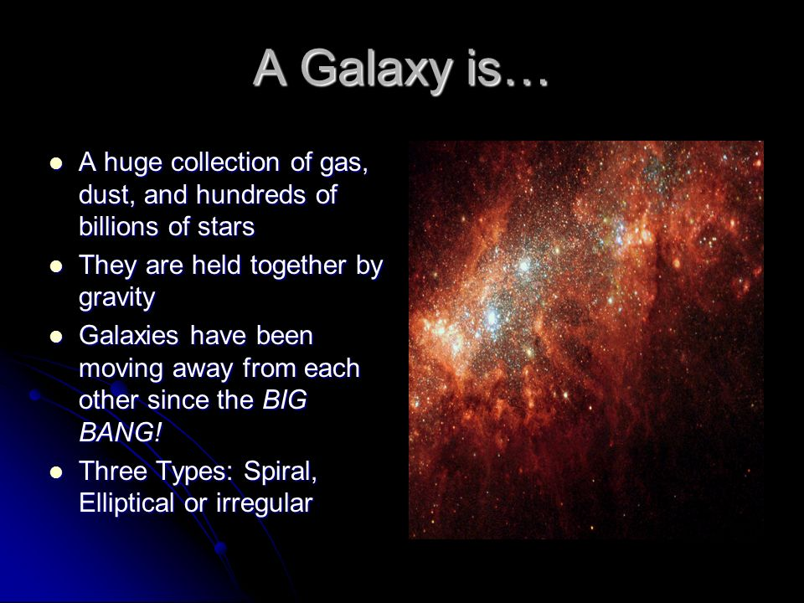
The Sun is a star in the galaxy known as the Milky Way.
The Milky Way Galaxy, Our Sun (a star) and all the planets around it are part of a galaxy known as the Milky Way Galaxy. All the stars we see in the night sky are in our own Milky Way Galaxy. Our galaxy is called the Milky Way because it appears as a milky band of light in the sky when you see it in a really dark area.
The Milky Way gets its name from a Greek myth about the goddess Hera who sprayed milk across the sky. ... This is what the Milky Way Galaxy looks like from Earth. Have you seen it in the night sky? If you could see our galaxy from the side, it would look like a huge, thin disk with a slight bump in the center.
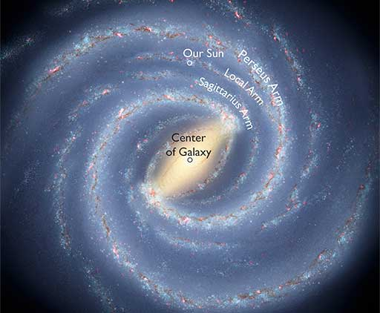
Astronomical distances measured in light-years:
Light-years A common method for measuring distance in space is to measure how far light travels in one year: known as a light-year, which is around 9.5 trillion km. If you want to be precise, the IAU regards a year as 365.25 days, making a light-year 9,460,730,472,580,800m.
The light year is used to measure distances in space because the distances are so big that a large unit of distance is required.

