CAMBRIDGE O LEVEL
TOPIC ASSESSMENT – UNIT 2
PAKISTAN STUDIES  Paper 2 The Environment of Pakistan  Topic Test: Climate of Pakistan | 2059/02  1 hour

You must answer on the question paper.
You will need: Ruler, protractor and calculator
INSTRUCTIONS
• This paper contains three questions. Answer any TWO questions.
• Each question carries 25 marks.
• Use a black or dark blue pen. You may use an HB pencil for any diagrams or graphs.
• Write your answers in the spaces provided.
• Where you are asked to develop your answer, give reasons and detail to support the points you make.
• In the final part of each question you must give reasons for your judgement and consider different points of view.
INFORMATION
• The total mark for this paper is 50 (2 × 25).
• The number of marks for each question or part question is shown in brackets [ ].
• Answer using the resource provided only where the question states this.

Question 1 Climate Graphs and Climate Regions
1 (a) (i) Study Fig. 1.1 and Fig. 1.2, climate graphs showing rainfall and temperature for Karachi and Peshawar.
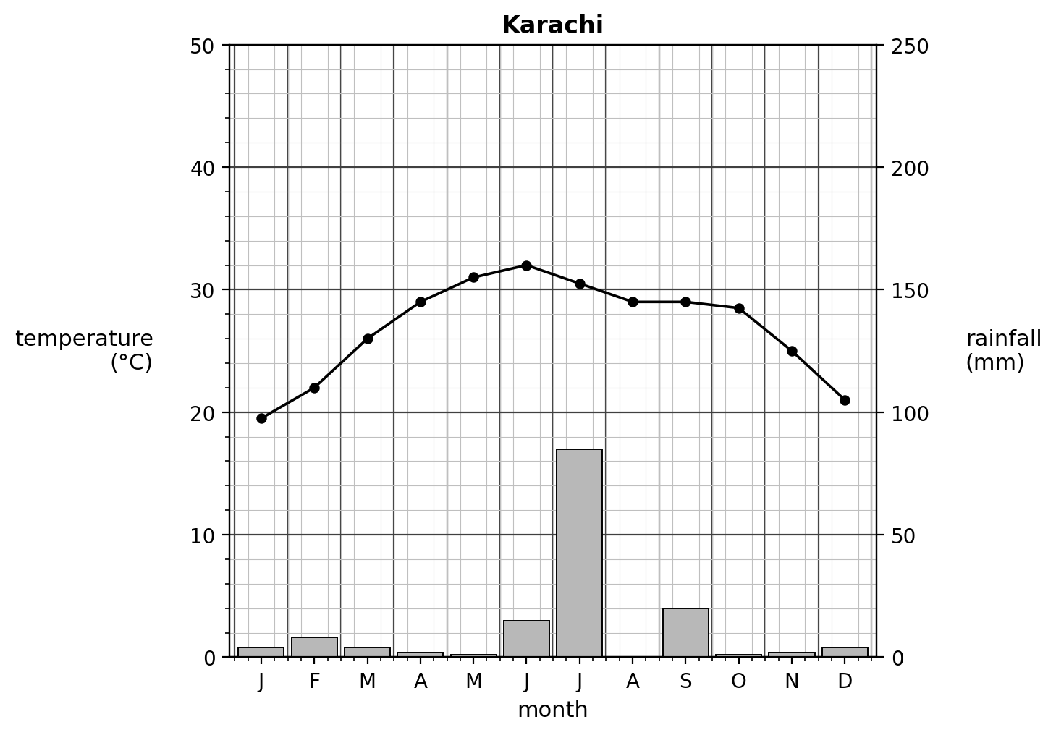
Fig. 1.1
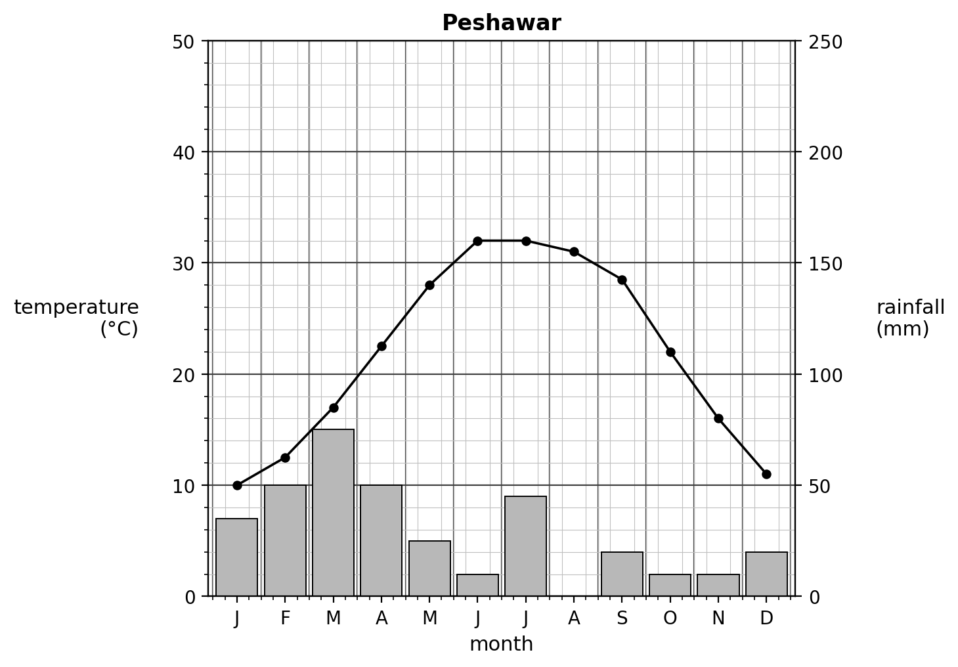
Fig. 1.2

Complete Fig. 1.1 and Fig. 1.2 to show the rainfall for Karachi and Peshawar in August using the information below.
 | rainfall (mm)
Karachi | 55
Peshawar | 60
[2]
(ii) Using Fig. 1.1 and Fig. 1.2 only, compare the climate of Karachi with the climate of Peshawar.
......................................................................................................................................................
......................................................................................................................................................
......................................................................................................................................................
.......................................................................................................................................... [3]
(iii) What type of climate region does Fig. 1.1 show? Suggest one reason for your answer.
climate region ....................................................................................................
reason ....................................................................................................................
................................................................................................................................ [2]
(b) (i) State three factors that affect temperature in Pakistan.
1 ..............................................................................................................................
2 ..............................................................................................................................
3 .............................................................................................................................. [3]
(ii) Describe the distribution of convectional rainfall and monsoon rainfall across Pakistan.
......................................................................................................................................................
......................................................................................................................................................
......................................................................................................................................................
.......................................................................................................................................... [3]
(iii) Explain the causes of the monsoon in Pakistan. You should develop your answer.
......................................................................................................................................................
......................................................................................................................................................
......................................................................................................................................................
......................................................................................................................................................
.......................................................................................................................................... [4]

(c) Suggest two ways in which latitude affects the climate of Pakistan.
1 ..............................................................................................................................
2 .............................................................................................................................. [2]
(d) Rainfall in Pakistan is becoming more variable, with both longer droughts and heavier monsoon downpours.
Evaluate the extent to which changing rainfall patterns are a greater problem for farmers than for people living in cities in Pakistan. Give reasons to support your judgement and refer to examples you have studied. You should consider different points of view in your answer.
......................................................................................................................................................
......................................................................................................................................................
......................................................................................................................................................
......................................................................................................................................................
......................................................................................................................................................
......................................................................................................................................................
......................................................................................................................................................
......................................................................................................................................................
......................................................................................................................................................
......................................................................................................................................................
......................................................................................................................................................
......................................................................................................................................................
......................................................................................................................................................
......................................................................................................................................................
......................................................................................................................................................
......................................................................................................................................................
......................................................................................................................................................
......................................................................................................................................................
......................................................................................................................................................
.......................................................................................................................................... [6]
[Total: 25]

Question 2 Rainfall, Monsoons and Cyclones
2 (a) Study Fig. 2.1, a map showing annual rainfall in Pakistan.
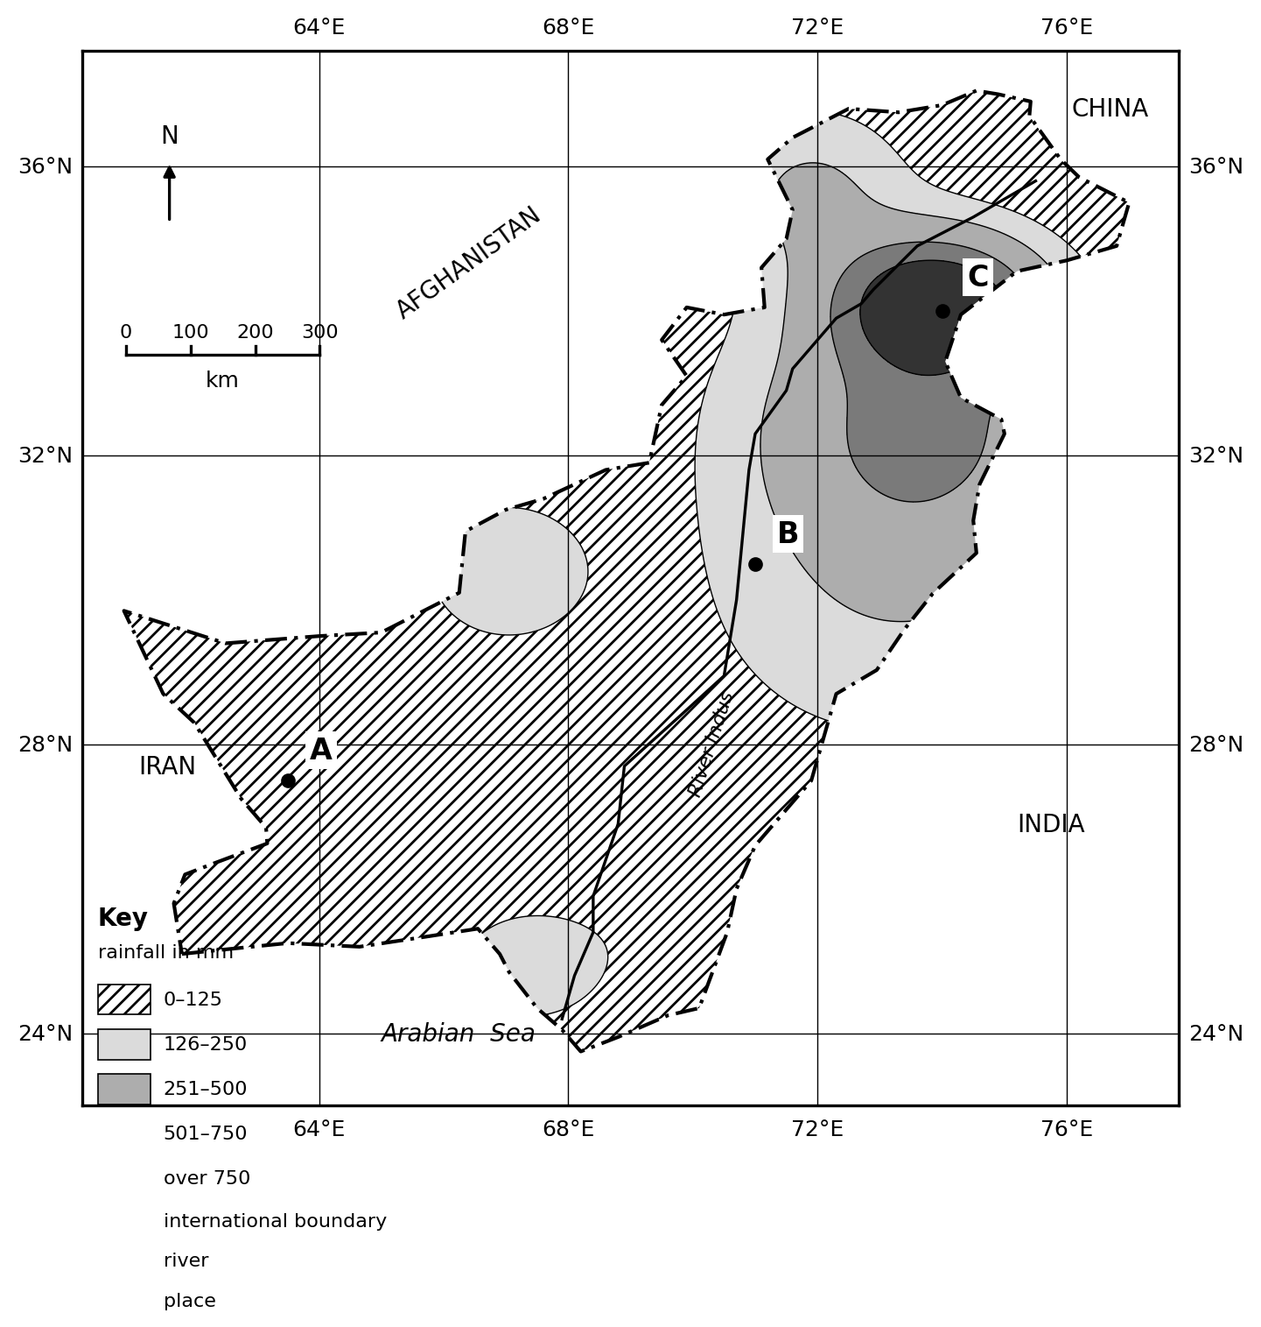
Fig. 2.1
(i) Using Fig. 2.1 only, describe the pattern of annual rainfall in Pakistan.
......................................................................................................................................................
......................................................................................................................................................
......................................................................................................................................................
.......................................................................................................................................... [3]
(ii) Using Fig. 2.1 only, state the annual rainfall received at the places labelled A and C.
A ..............................................................................................................................
C .............................................................................................................................. [2]
(b) (i) Define the term ‘western depression’.
................................................................................................................................ [1]

(ii) Describe how relief rainfall is formed in Pakistan.
......................................................................................................................................................
......................................................................................................................................................
......................................................................................................................................................
......................................................................................................................................................
.......................................................................................................................................... [4]
(iii) Explain two reasons why south-western Balochistan receives very little rainfall. You should develop your answer.
1 ..............................................................................................................................
......................................................................................................................................................
..........................................................................................................................................
2 ..............................................................................................................................
......................................................................................................................................................
.......................................................................................................................................... [4]
(c) (i) Which of the following statements about monsoons in Pakistan are correct? Tick (✓) three boxes in the table below.
tick (✓)
During winter a low-pressure area is created over the Tropic of Cancer.
Monsoons are seasonal.
Monsoon winds are seasonally reversed and driven by temperature differences between the land and sea.
Monsoon winds blow towards the centre of the subcontinent during winter and towards the sea in summer.
Summer winds are called north-west monsoons.
Winter winds are called north-east monsoons.
[3]
(ii) Study Fig. 2.2, a photograph of a recent cyclone in South Asia. Using Fig. 2.2 only, describe two impacts of the cyclone shown.
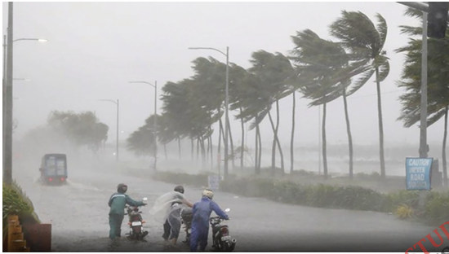
Fig. 2.2
1 ..............................................................................................................................
2 .............................................................................................................................. [2]
(d) Scientific evidence suggests that cyclones are likely to continue to increase in severity and frequency across South Asia due to climate change.
Evaluate the influence of storms such as cyclones on secondary and tertiary industries in Pakistan. Give reasons to support your judgement and refer to examples you have studied. You should consider different points of view in your answer.
......................................................................................................................................................
......................................................................................................................................................
......................................................................................................................................................
......................................................................................................................................................
......................................................................................................................................................
......................................................................................................................................................
......................................................................................................................................................
......................................................................................................................................................
......................................................................................................................................................
......................................................................................................................................................
......................................................................................................................................................
......................................................................................................................................................
.......................................................................................................................................... [6]
[Total: 25]

Question 3 Climate Regions, Temperature and Climate Change
3 (a) Study Fig. 3.1, a map showing the climate regions of Pakistan.
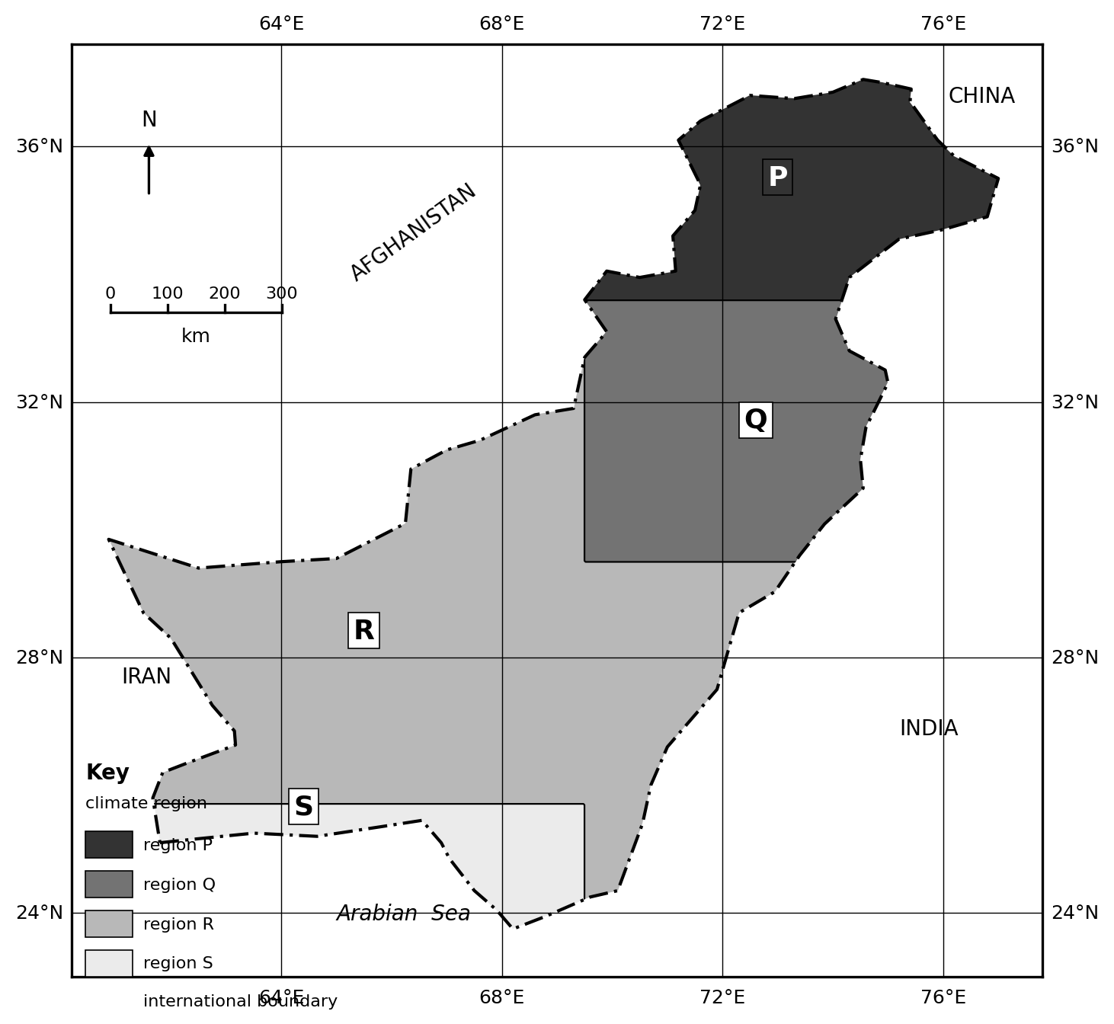
Fig. 3.1
(i) Name the climate regions labelled P, Q and S on Fig. 3.1.
P ..............................................................................................................................
Q ..............................................................................................................................
S .............................................................................................................................. [3]
(ii) Using Fig. 3.1 only, describe the distribution of climate region R.
......................................................................................................................................................
......................................................................................................................................................
......................................................................................................................................................
.......................................................................................................................................... [3]

(b) (i) Study Fig. 3.2, a graph showing mean January and July temperatures for four cities in Pakistan.
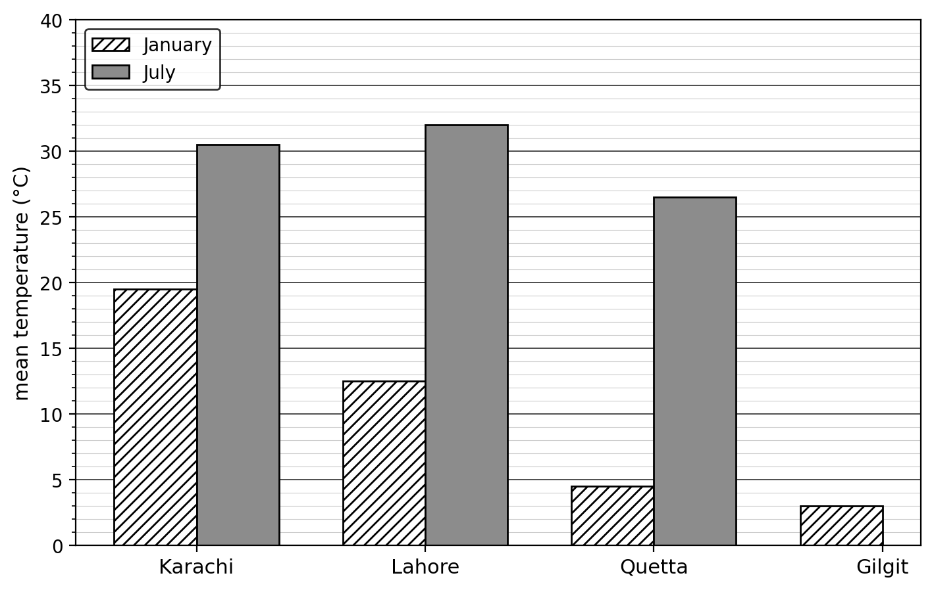
Fig. 3.2
Complete Fig. 3.2 to show that the mean July temperature of Gilgit is 25 °C.
[2]
(ii) Using Fig. 3.2 only, describe the pattern of temperature shown for the four cities.
......................................................................................................................................................
......................................................................................................................................................
......................................................................................................................................................
.......................................................................................................................................... [3]
(iii) Explain two ways in which altitude and distance from the sea affect temperature in Pakistan. You should develop your answer.
1 ..............................................................................................................................
......................................................................................................................................................
..........................................................................................................................................
2 ..............................................................................................................................
......................................................................................................................................................
.......................................................................................................................................... [4]
(c) Explain two problems caused for people in Pakistan’s large cities by very high summer temperatures. You should develop your answer.
1 ..............................................................................................................................
......................................................................................................................................................
..........................................................................................................................................
2 ..............................................................................................................................
......................................................................................................................................................
.......................................................................................................................................... [4]
(d) Evaluate the extent to which climate change is a greater threat to agriculture than to human health in Pakistan. Give reasons to support your judgement and refer to examples you have studied. You should consider different points of view in your answer.
......................................................................................................................................................
......................................................................................................................................................
......................................................................................................................................................
......................................................................................................................................................
......................................................................................................................................................
......................................................................................................................................................
......................................................................................................................................................
......................................................................................................................................................
......................................................................................................................................................
......................................................................................................................................................
......................................................................................................................................................
......................................................................................................................................................
......................................................................................................................................................
......................................................................................................................................................
......................................................................................................................................................
......................................................................................................................................................
......................................................................................................................................................
......................................................................................................................................................
......................................................................................................................................................
......................................................................................................................................................
......................................................................................................................................................
......................................................................................................................................................
.......................................................................................................................................... [6]
[Total: 25]

