CAMBRIDGE O LEVEL
TOPIC ASSESSMENT – UNIT 1
PAKISTAN STUDIES  Paper 2 The Environment of Pakistan  Topic Test: Topography and Drainage of Pakistan | 2059/02  1 hour

You must answer on the question paper.
You will need: Ruler, protractor and calculator
INSTRUCTIONS
• This paper contains three questions. Answer any TWO questions.
• Each question carries 25 marks.
• Use a black or dark blue pen. You may use an HB pencil for any diagrams or graphs.
• Write your answers in the spaces provided.
• Where you are asked to develop your answer, give reasons and detail to support the points you make.
INFORMATION
• The total mark for this paper is 50 (2 × 25). Questions on this paper total 75 marks.
• The number of marks for each question or part question is shown in brackets [ ].
• Answers should be based on Fig. sources only where the question states this.

Question 1 The Northern and South-Western Highlands
1 (a) Study Fig. 1.1, a map showing southern Pakistan and surrounding countries.
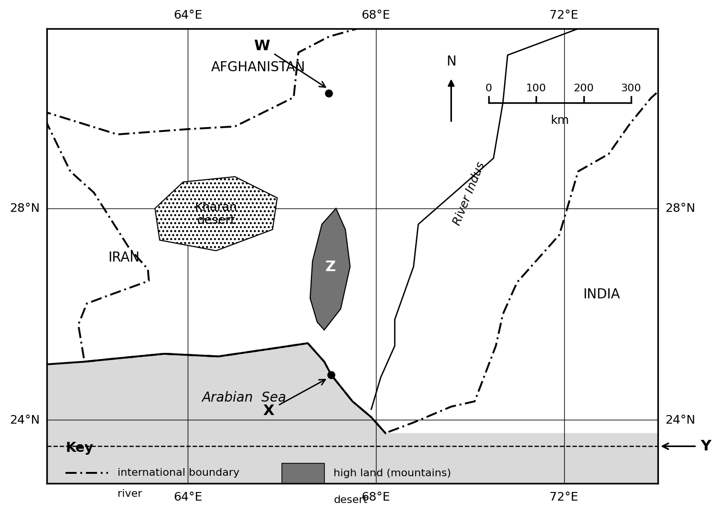
Fig. 1.1
(i) Name the two cities labelled W and X and the mountain range labelled Z on Fig. 1.1.
W ..............................................................................................................................
X ..............................................................................................................................
Z .............................................................................................................................. [3]
(ii) Using Fig. 1.1 only:
– state the straight-line distance between city X and city W.
................................................................................................................................
– state the direction of city X from city W.
................................................................................................................................ [2]
(iii) Identify the line of latitude labelled Y on Fig. 1.1.
Y .............................................................................................................................. [1]
(iv) Using Fig. 1.1 only, describe the location of the mountains labelled Z.
......................................................................................................................................................
......................................................................................................................................................
......................................................................................................................................................
.......................................................................................................................................... [3]
(b) (i) Define and give an example of ‘natural topography’.
definition ............................................................................................................
................................................................................................................................
example .................................................................................................................. [2]
(ii) Describe the natural topography of the northern regions of Pakistan.
......................................................................................................................................................
......................................................................................................................................................
......................................................................................................................................................
.......................................................................................................................................... [3]
(iii) Describe the importance of the Northern Mountains to Pakistan.
......................................................................................................................................................
......................................................................................................................................................
......................................................................................................................................................
......................................................................................................................................................
.......................................................................................................................................... [4]
(c) Study Fig. 1.2, a photograph of a landscape in the Northern Mountains of Pakistan.
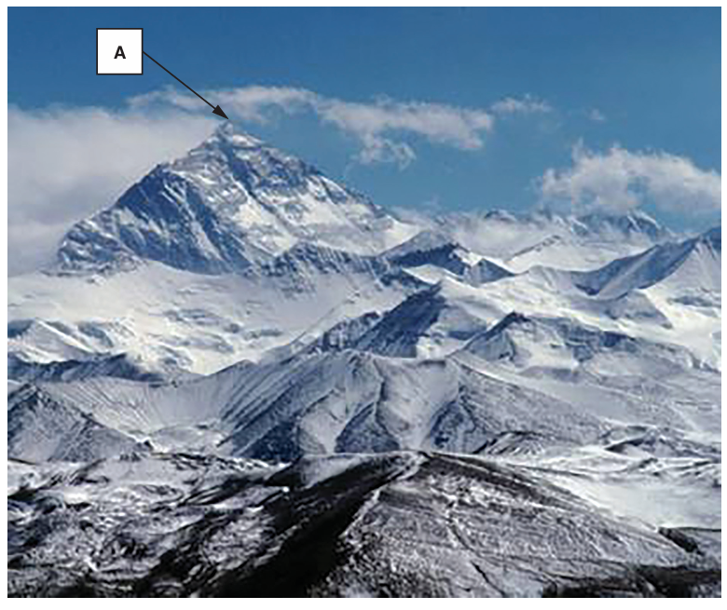
Fig. 1.2
(i) Name the feature of the natural topography labelled A on Fig. 1.2.
A .............................................................................................................................. [1]
(ii) Using Fig. 1.2 only, describe two other features of the natural topography shown in the photograph.
......................................................................................................................................................
......................................................................................................................................................
.......................................................................................................................................... [2]
(iii) Explain two ways in which the natural topography of the Northern Mountains makes the construction of roads difficult. You should develop your answer.
1 ..............................................................................................................................
......................................................................................................................................................
..........................................................................................................................................
2 ..............................................................................................................................
......................................................................................................................................................
.......................................................................................................................................... [4]
[Total: 25]

Question 2 Rivers, Plains and Deserts
2 (a) Study Fig. 2.1, a map showing the drainage of Pakistan.
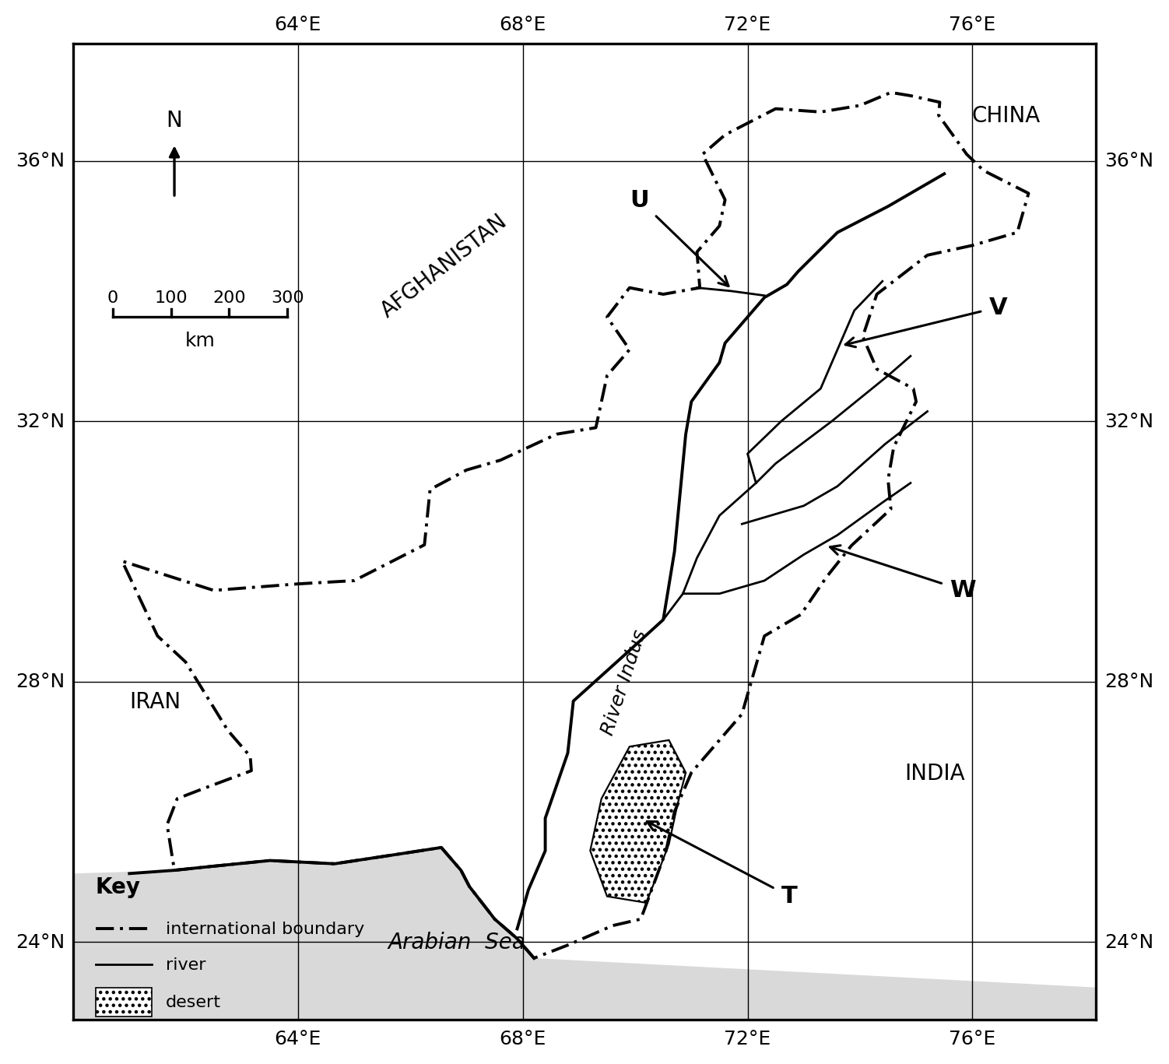
Fig. 2.1
(i) Name the rivers labelled U, V and W shown on Fig. 2.1.
U ..............................................................................................................................
V ..............................................................................................................................
W .............................................................................................................................. [3]
(ii) Using Fig. 2.1 only, describe the location of the desert labelled T.
......................................................................................................................................................
......................................................................................................................................................
......................................................................................................................................................
.......................................................................................................................................... [3]
(b) (i) Define the term ‘doab’ and give an example of one doab of Pakistan.
definition ............................................................................................................
example .................................................................................................................. [2]
(ii) Describe the natural topography of the Upper Indus Plain.
......................................................................................................................................................
......................................................................................................................................................
......................................................................................................................................................
......................................................................................................................................................
.......................................................................................................................................... [4]
(iii) Describe the natural topography of the desert areas of Pakistan.
......................................................................................................................................................
......................................................................................................................................................
......................................................................................................................................................
.......................................................................................................................................... [3]
(c) (i) Explain the importance of the River Indus and its tributaries to the people and economy of Pakistan. You should develop your answer.
......................................................................................................................................................
......................................................................................................................................................
......................................................................................................................................................
......................................................................................................................................................
.......................................................................................................................................... [4]
(ii) Explain three difficulties faced by people living in the desert areas of Pakistan. You should develop your answer.
1 ..............................................................................................................................
..........................................................................................................................................
2 ..............................................................................................................................
..........................................................................................................................................
3 ..............................................................................................................................
.......................................................................................................................................... [6]
[Total: 25]

Question 3 Plateaus and the Salt Range
3 (a) Study Fig. 3.1, a map showing the natural topography of southern and western Pakistan.
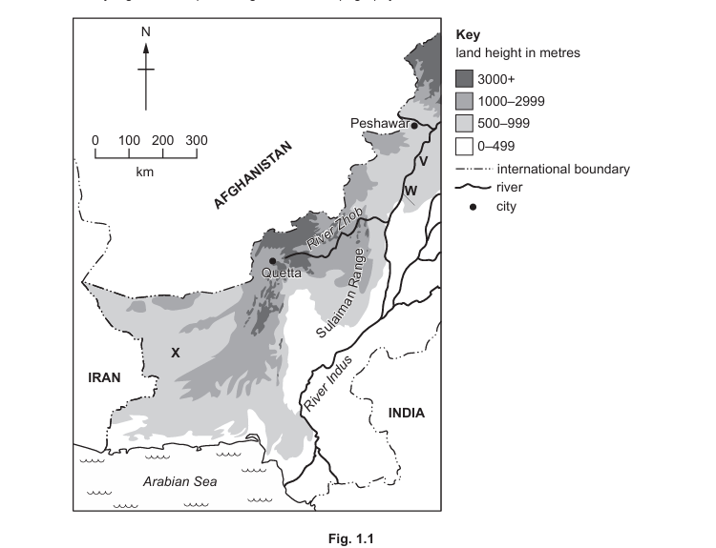
Fig. 3.1
For the landforms labelled V, W and X on Fig. 3.1, circle the correct answer below:
(i) V
Balochistan Plateau | Potwar Plateau | Salt Range | [1]
(ii) W
Balochistan Plateau | Potwar Plateau | Salt Range | [1]
(iii) X
Balochistan Plateau | Potwar Plateau | Salt Range | [1]
(iv) Using Fig. 3.1 only, describe the location of the Sulaiman Range.
......................................................................................................................................................
......................................................................................................................................................
......................................................................................................................................................
.......................................................................................................................................... [3]
(b) (i) Study Fig. 3.2, a photograph of the Salt Range. Using Fig. 3.2 only, describe two features of the Salt Range.
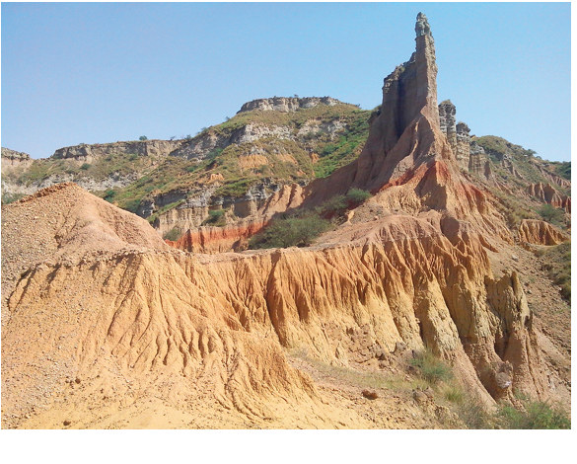
Fig. 3.2
......................................................................................................................................................
......................................................................................................................................................
.......................................................................................................................................... [2]
(ii) Name two minerals that can be obtained from the Salt Range and suggest one use for each.
mineral 1 ..............................................................................................................
use ..........................................................................................................................
mineral 2 ..............................................................................................................
use .......................................................................................................................... [4]
(iii) Describe the natural topography of the Potwar Plateau.
......................................................................................................................................................
......................................................................................................................................................
......................................................................................................................................................
.......................................................................................................................................... [3]
(c) (i) Explain two ways in which the natural topography of the Salt Range makes mineral exploitation difficult. You should develop your answer.
1 ..............................................................................................................................
......................................................................................................................................................
..........................................................................................................................................
2 ..............................................................................................................................
......................................................................................................................................................
.......................................................................................................................................... [4]
(ii) Explain three ways in which the natural topography of the Balochistan Plateau makes development difficult for the people who live there. You should develop your answer.
1 ..............................................................................................................................
..........................................................................................................................................
2 ..............................................................................................................................
..........................................................................................................................................
3 ..............................................................................................................................
.......................................................................................................................................... [6]
[Total: 25]

